**Fair Treatment of Vulnerable Customers**

**Our Promise**

**Cara Glass Ltd have a “Fair Treatment of Vulnerable Customers” Policy which applies to all employees and subcontractors who interact with our customers. Employees and subcontractors shall be referred to as ‘we’ ‘our’ and ‘us’ throughout this policy.**

At Cara Glass Ltd we have an engrained culture of employing and subcontracting with respectable people who will be fair and honest with all our customers. Our fair, honest and transparent pricing structure, documented written quotes, signed surveys and contracts ensure that our customers are in control of all the decisions that they make when interacting with us. We should never act inappropriately **or** put ourselves in any position where it could be perceived by others that we have acted inappropriately or taken advantage of anyone or any situation.

**The definition of a vulnerable person is ‘someone who is more susceptible to harm because of their current status.’**

Examples of vulnerable persons include (not exhaustive):

Someone who is disadvantaged (physically or mentally) in their ability to look after themselves or their finances **at the time of our interaction** or may require support to do so.

Vulnerability characteristics include, but are not limited to:

* people for who English is not a strong language,
* people who have suffered recent bereavement,
* people who have had a recent significant life change i.e. loss of job, divorce,
* people who are isolated from family and friends,
* people with dementia or similar conditions,
* people appearing confused or repeating or asking out of context questions,
* people with a disability (including sight loss),
* people with hearing difficulties,
* people with learning difficulties,
* people under the influence of drink or drugs (illegal or prescribed),
* people living with addictions,
* people whose living conditions are poor,
* people with low literacy or numeracy skills,

Cara Glass Ltd have an obligation to protect vulnerable people and people in vulnerable circumstances. Whenever we suspect someone is vulnerable, we MUST take action to make sure we are protecting their best interests.

**Our Action:**

If **any employee or subcontractor who interacts with our customers** suspects that a person they are talking to may be vulnerable, they must **not proceed with any work** until they ascertain that this person is able to act for themselves.

Ask non-intrusive questions to understand the customer’s circumstances, which will allow us to identify if the customer is in fact vulnerable and how our approach will need to be tailored for that customer.

**Just because a customer says they are not vulnerable and can act for themselves, it still could mean that they fall within the criteria of this policy therefore these situations must still be reported.**

Where the customer confirms that they have vulnerability acknowledge the existence of the vulnerable circumstance and discuss the individual’s capacity to proceed.

Typically, we would only look to record the details of a customer’s vulnerability where we may need to tailor our approach during our interactions with them i.e. when we are entering their home for the purposes of a sales consultation or installation. We would therefore only share the details of the vulnerability with the relevant staff and representatives.

Any such interactions that fall within the guidelines of this policy must be reported to the Office Team at Cara Glass Ltd who will support in managing the customer information and our ongoing interactions in the right way.

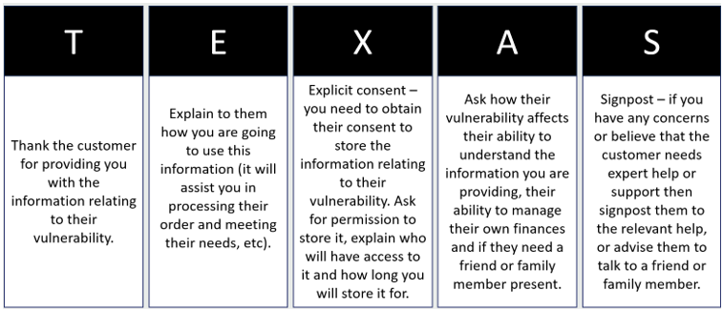

**Sales Contract Cooling Off Period:**

At Cara Glass Ltd, we offer a 14-day cooling-off period for all Sales Orders. This is where the customer has 14 days, after signing any sales contract, to think about the decision they have made and if they wish to cancel the order they can do so. No work must progress during the cooling off period.

**Finance Agreement Cooling Off Period:**

At Cara Glass Ltd, we provide the statutory 14-day cooling-off period for all Finance Agreements. This is where the customer has 14 days, after signing any Finance Agreement, to think about the decision they have made and if they wish to cancel the Agreement they can do so. No work must progress during the cooling off period.

Cara Glass is authorised and regulated by the Financial Conduct Authority FRN 1039835.

**If there are any questions regarding this policy or if you need any further advice, please call our office team on 01722 744424 or email:** [info@caraglass.com](mailto:info@caraglass.com)

Name: __________________________ Signed ________________________________

Date: __________________________